QA Fundamentals and Manual Testing Retake Exam


Part I – Revue Crafters Web Application
You are provided with a web application, Revue Crafters, along with a specification of the requirements. The primary objective of the exam is to ensure the App functions as expected according to the provided use cases. This involves creating test cases for each of the USE CASES. It also includes the detection and detailed documentation of any identified bugs. You have to document all your work in the provided Test Management and Bug Tracker Template.

Software Requirements

1. Introduction

1.1. Purpose
The objective of this document is to provide a description of the Revue Crafters application (also referred to as Revue Crafters or The App). It will present an overview of the key functionalities.

1.2. Scope
This document includes high-level descriptions of the basic functionalities of Revue Crafters, such as user registration, login, profile editing, revue creation and management. It does not cover any special user (Administrator) functionalities.

2. Overall Description

2.1. System environment
The App hosts two primary actors: unregistered/non-logged users and registered/logged users. Both can access their respective parts of the application via the internet on the following url:

https://d3s5nxhwblsjbi.cloudfront.net/

2.2. Key Features
Unregistered/non-logged users have access only to the Home page of The App, with the option to either REGISTER or LOGIN. On the other hand, registered/logged users have access to the main functionalities, including Profile editing, Revue creation, and Revue management.

2.2.1. Home Page for unregistered / non-logged users
The Home Page is the main gateway into The App. It contains a navigation bar (also referred to as Navbar) on top, with Home, About and Services buttons on the left and REGISTER and LOGIN buttons on the right. The Home page of the web application is designed with a scrollable layout. Each of the buttons on the Navbar, upon clicking scrolls the page to its corresponding section.
Upon loading, users will be presented with an image and below this initial image, the page is divided into sections, each serving a specific purpose.
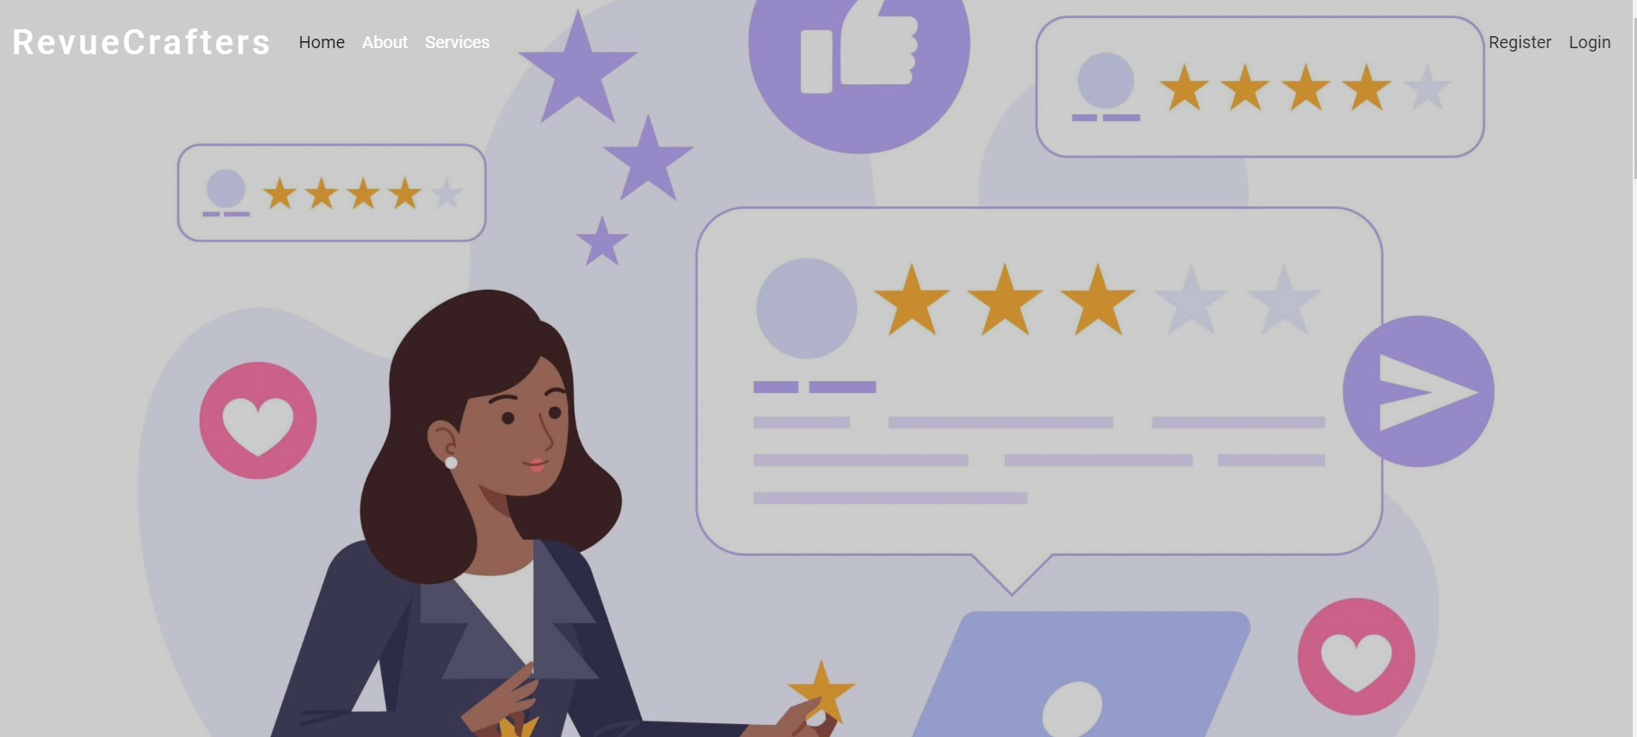

Below, the initial image the first section is titled: Explore the World of Reviews
This section includes a picture and a short description of what one might expect from the App.


The second section: There is no limitations!!!
This section features three images, each accompanied by corresponding text, encouraging users to explore their creative potential within the realm of reviews: Inspiration Unleashed, Endless Exploration, and Community. This section can be reached via scrolling or by clicking on SERVICES button on the Navbar.
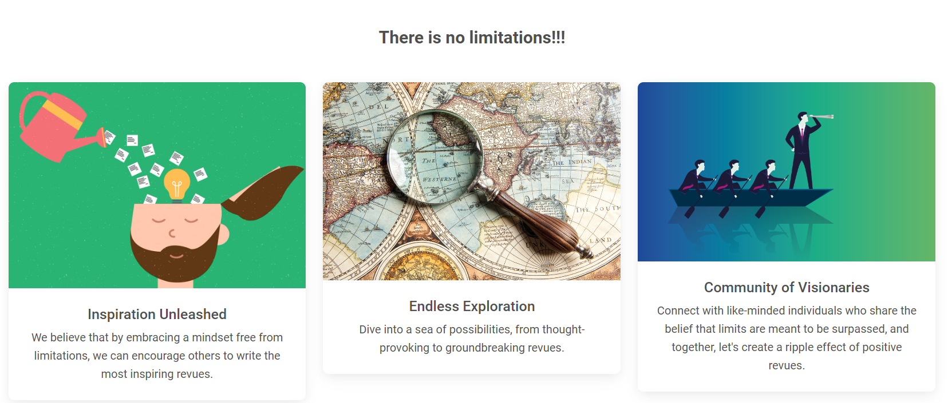
Section three: Join the RevueCrafter Community Today - Just Sign Up for Free
This section prompts users to become part of the RevueCrafter community through a simple sign-up process. The form includes fields for the user's username, email, password, and repeat password, along with SIGN UP button. The form can be reached via scrolling or by clicking on REGISTER button on the Navbar.
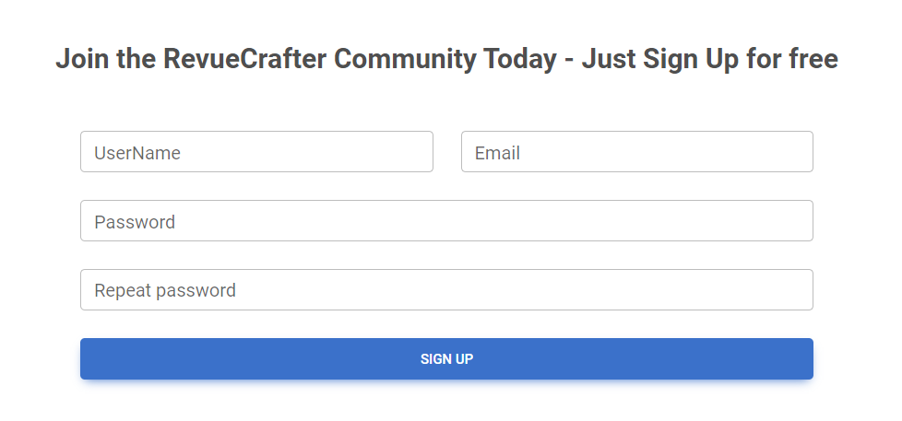

Section four: About Us
Holding information about the purpose and the idea behind creating the App.
This section can be reached via scrolling or by clicking on About button on the Navbar.


Section five: Already Have an Account?
Welcoming returning users, this section features a LOG IN button, which leads to the Log in page.


Footer: Copyright Information
The footer of the home page bears the copyright notice: "© 2023 Copyright: RevueCrafters," indicating the ownership and protection of intellectual property.

RevueCrafters part of the text is clickable and it leads to Terms of Service page.
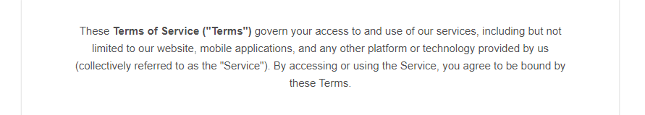

2.2.2. Sign Up Form
The Sign Up Form is accessed by scrolling down the Home page or by clicking REGISTER button on the Navbar. It contains form fields for entering a Username, Email, Password, and Repeat password. The form also includes a Sign Up button to submit the form. The acceptable requirements for each field are specified as follows:
Username: A 2-30 character field, accepting all character types.
Email: Requires a valid email, 6-254 characters long.
Password: Any characters are acceptable, with a length of 6-30 characters
Repeat Password: Must match password

2.2.3. Log In Page
The Log In page can be reached from the Navbar LOGIN button or by scrolling down the Home page to section five: Already Have an Account? and clicking LOGIN button there.
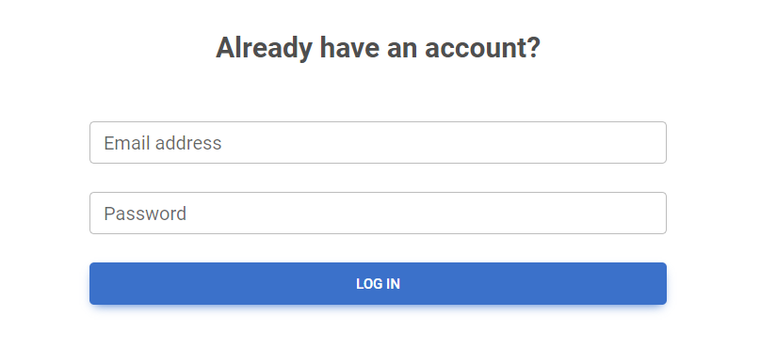

2.2.4. Home Page for logged users
Once a user is logged in, they are directed to a different version of the Home page. The page includes a Navbar on top, with links to MY REVUES and CREATE REVUE on the left, and PROFILE and LOGOUT buttons on the right. The page again is scrollable, the initial image is the same and below the image "Dear, {username} It's a pleasure to have you here again, back in the heart of the RevueCrafter community…. " message is showing.


2.2.5. Profile Page
This page is accessible for logged users from the Navbar, top-right PROFILE button. It includes a default empty profile picture, an EDIT PROFILE button, an empty About section by default, and a counter of the user's revues, which is initially set to 0. If no revues have been created yet, the Recent revues section shows a No revues message. There is also a Show all link which leads to My Revues page.
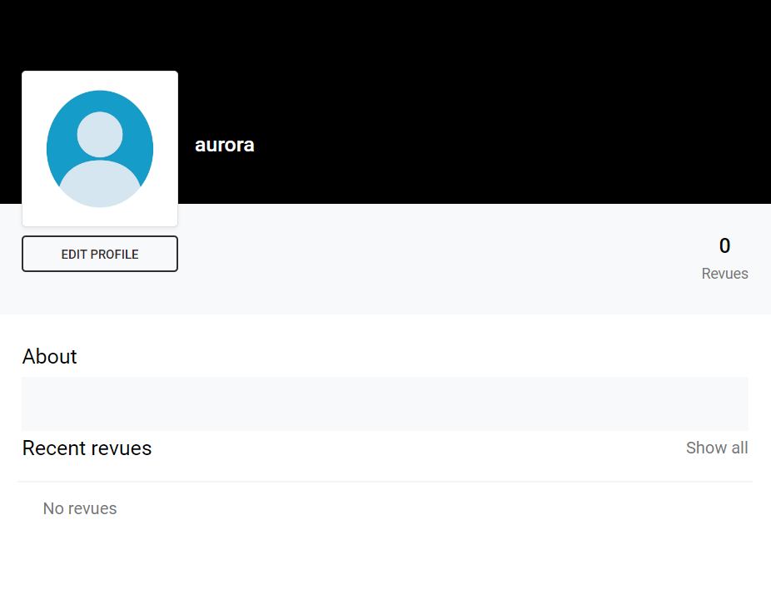

2.2.6. Edit Profile Info Page
Accessible from EDIT PROFILE button on Profile page, this page allows users to edit their profile information, including Profile picture (picture is not uploaded, but must be a valid URL of a picture, for example http://......jpg), First name (max 60 characters length), Last name (max. 60 characters length), City (max. 120 characters length), and a Describe yourself section (max. 256 characters length).
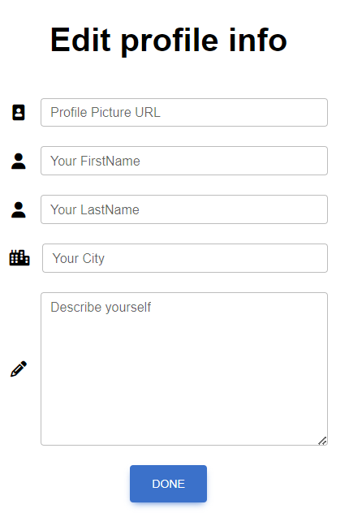
Upon clicking on DONE button, it redirects to My Profile page, where the newly provided information is visible.

2.2.7. My Revues Page
This page is accessible from the Navbar and contains a Search revues field and a SEARCH button. If no revues have been created yet, a No revues yet! message is displayed.

Upon Creating a revue, it appears on the My Revues page where the user can VIEW, EDIT, or DELETE it.
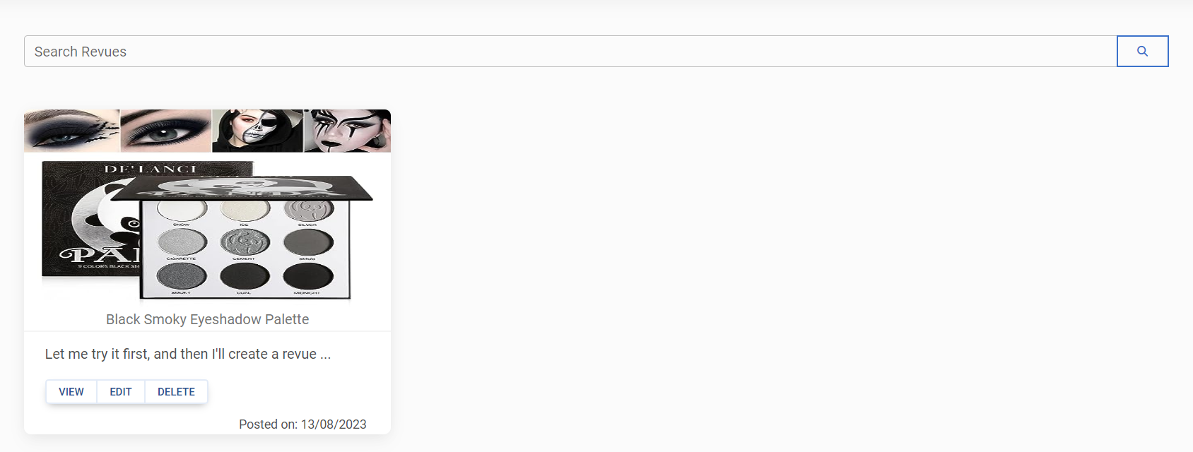

Users can enter keywords from the title of a revue and click the Search button to initiate the search. The search functionality then filters the list of revues based on their titles.
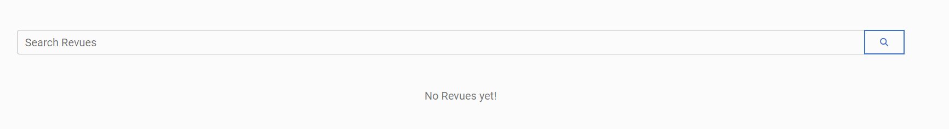

2.2.8. Create Revue Page
This page is accessible from the Create Revue link on the Navbar and contains the following: Title field (min. 2 characters - max. 70 characters length), Add a picture field (picture is not uploaded, but must be a valid URL of a picture, for example http://......jpg), Describe your revue field (min. 3 characters - max. 400 characters length), and CREATE button.
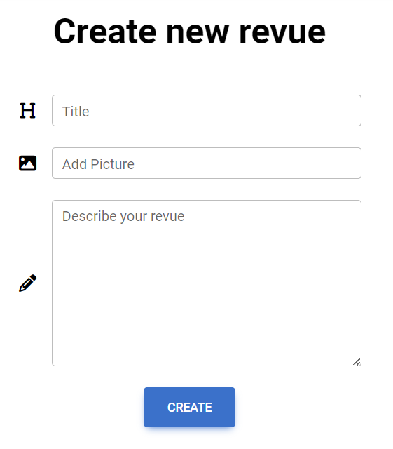
Upon creating a Revue, it redirects to My Revues page, where the new added Revue is present buttons for VIEW, EDIT, and DELETE

2.2.8. Revue Management
Revue Functionalities are available from the My Revues page. Each created Revue has its own VIEW, EDIT and DELETE buttons.
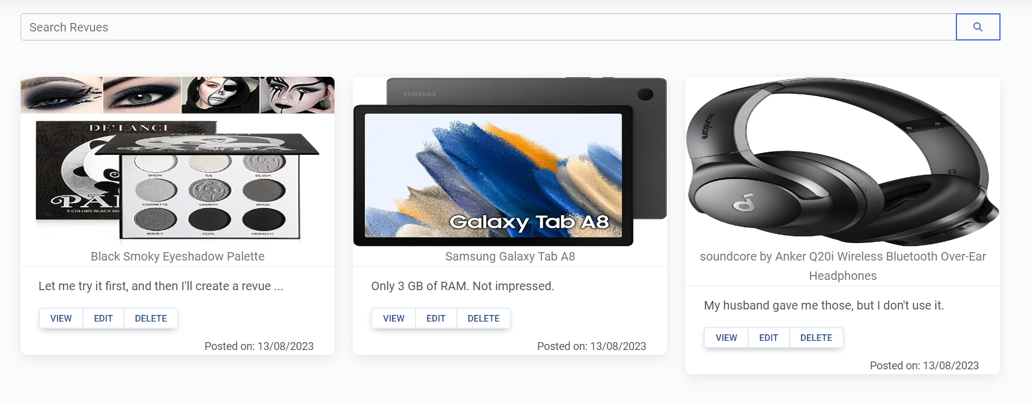

а. VIEW
Available after clicking on VIEW button. The user should be able to VIEW the revue and also EDIT and DELETE it, through the small blue buttons on the bottom right.
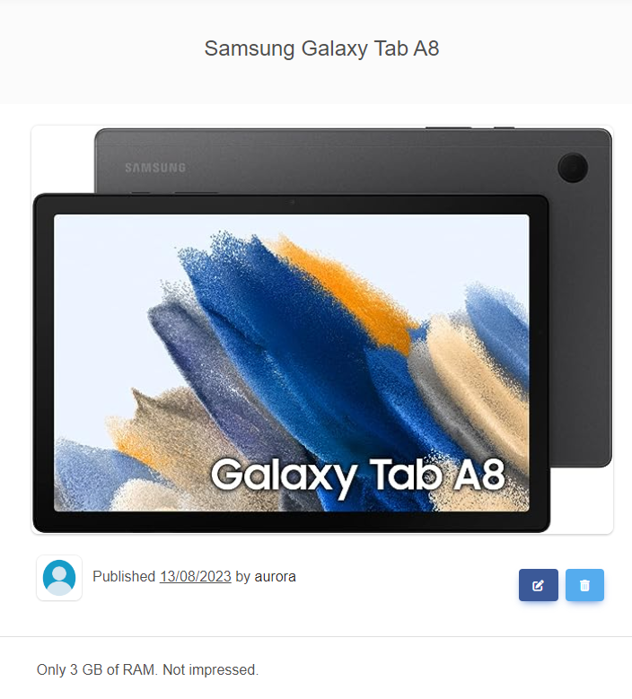

b. EDIT
Available after clicking on EDIT button.
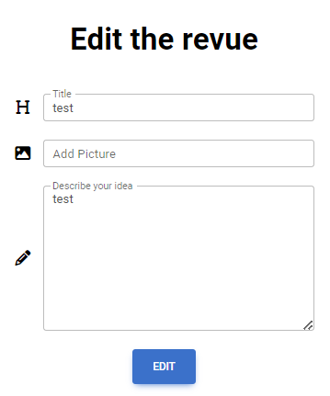

c. DELETE
After clicking on DELETE button, the Revue is deleted and it disappers from My Revues page.

Functional Requirements

1. Use Case 1 (Home Page)
Users should be able to access The Revue Crafters App from its designated URL via the Internet, which should load the Home page, appropriate to the user's logged-in status (unregistered/non-logged or registered/logged).

2. Use Case 2 (User Registration)
Unregistered users should be able to successfully go through the Sign Up process. This involves the utilization of fields such as Username, Email, Password and Repeat Password, all subject to their respective constraints and character type acceptance.

3. Use Case 3 (User Login)
Registered users should be able to successfully go through the Log In process. They should be able to log in using Email and Password.

4. Use Case 4 (Profile Management)
Upon successful Log In, logged users should be able to navigate to their Profile page, edit their profile details, and view their Revues count. This involves the changing of profile picture inserted via URL, and editing of user data fields including First Name, Last Name, City and About me sections.

5. Use Case 5 (Revue Creation)
Logged users should be able to navigate to the Create Revue page, where they can create a new Revue with a Title, Picture (URL), and a Description. After the Revue creation process, users should be redirected to My Revues page, where the newly created revue should be present.

6. Use Case 6 (Revue Management)
On My Revues page, logged users should see all their revues listed. Each revue should have options for View, Edit, and Delete. If no revues have been created yet, a "No revues Yet!" message should be displayed. Users also should have the option to search for revues, based on revue’s title.

Revue Web App Tasks

1. Test Cases
You need to write test cases for each of the 6 Use cases.
Each Use case should have at least 2 Test Cases.
You should write at least 15 test cases.

2. Bug Reports
You should find and describe at least 5 bugs.
2 of the bugs should have high priority OR blocking/critical severity.

3. Template
Use the provided Test-Management-and-Bug-Tracking-Template.xlsx to document your work.

Part II – Revue Crafters API
This section provides information about the Revue Crafters API endpoints and their functionalities. It serves as a guide to understand how to interact with the Revue Crafters API. This is the base URL:
https://d2925tksfvgq8c.cloudfront.net
The following endpoints are supported:

1. User
POST /api/User/Create – create a new user: post a JSON object in the request body, e.g.
{ "userName": "string", "email": "user@example.com", "password": "string", "rePassword": "string", "acceptedAgreement": true }

- POST /api/User/Authentication: log in an existing user (post a JSON object in the request body, e.g. { "email": "user@example.com", "password": "string"})

Access Token
- When a user logs in, the response format is JSON object, e.g.
{"email": " user@example.com", "password": "string", "accessToken": "eyJhbGciOiJ…"}

NB! Access token is needed for all revue requests. It should be placed under the Authorization tab, Bearer Token option.

2. Revue
All of the following requests require Authorization.
- GET /api/Revue/All – list all revues (empty request body)

- POST /api/Revue/Create – create a new revue: post a JSON object in the request body, e.g.
{ "title": "string", "url": "", "description": "string" }

- PUT /api/Revue/Edit– replace the existing revue with the new one: post a JSON object in the request body, e.g. {"title": "string", "url": " ", "description": "string" };
Requires queryParameter: ?revueId={revueId}
HINT:

- DELETE /api/Revue/Delete – delete existing revue;
Requires queryParameter: ?revueId={revueId}
HINT:

Review Crafters API Tasks: Postman Requests
Your task is to write API requests with Postman for certain RESTful API endpoints.
You should organize your requests in a collection.

1. Log in to the API
Send a POST request with your email and password, that you previously created from the Review Crafters Web App. If properly executed, you will receive your access token as a part of the response body. Use it as a Bearer Token in the Authorization section for the next requests.

2. Create a new revue
Send a POST request with the attributes needed for creating a new review
Keep in mind that the full attributes in the JSON body are as follows:
{ "title": "string", "http://...jpg ", "description": "string" }
URL attribute is not mandatory, meaning that you can create a revue only with title and description. If you decide to use the url attribute, notice, that it has to point to a picture format or it can be left blank.

3. List all revues
Send a GET request to receive a list of all created revues.
This request will return all revues created through your profile. So, if you created any revues via the Web App, they also will be listed. In the list of revues, find the revue that you just created. You will need its id for the next request.

4. Change the title of the revue you created
Send a PUT request with the attributes needed to replace the revue you created in 2. Create a new revue task.

5. Delete Revue
Send a DELETE request with the attributes needed for deleting the revue you just edited.

How to submit your work
1. Create a .zip or .rar archive containing the following:
- Test-Management-and-Bug-Tracker.xlsx file with your work;
- JSON file containing your collection of requests, created via Postman.
2. Upload your archive on the SoftUni website, into Retake Exam section.
- It's the same as uploading your homework.
- Only the last uploaded archive will be taken into account for grading, so double-check your files before submitting.
- If you upload multiple archives, the previous ones will be overwritten, and only the most recent upload will be considered.

